Leading University
Department of Computer Science and Engineering
Course Code: 3240



Nilanta Roy Nilay
Zannatul Ferdaus Prome
Jubayda Sultana
FitTrack

0182310012101135
0182310012101133
0182310012101096

Department of Computer Science and Engineering

Supervisor
Md. Ebrahim Hossain
Assistant Professor
Department of Computer Science and Engineering

FitTrack


A Project submitted to the
Department of Computer Science and Engineering
Leading University
Sylhet - 3112, Bangladesh
in partial fulfillment of the requirements for the degree of
Bachelor of Science in Computer Science and Engineering

Nilanta Roy Nilay
Zannatul Ferdaus Prome
Jubayda Sultana
By

Supervisor
Md. Ebrahim Hossain
Assistant Professor

0182310012101135
0182310012101133
0182310012101096

Department of Computer Science and Engineering

Recommendation Letter from the Project Supervisor
The project entitled "FitTrack" submitted by the students

- Nilanta Roy Nilay,0182310012101135

- Zannatul Ferdaus Prome,0182310012101133

- Jubayda Sultana,0182310012101096

This is a record of research work carried out under my supervision, and I hereby approve that the report be submitted in partial fulfillment of the requirements for the award of their bachelor’s degrees.

Signature of the Supervisor: Md. Ebrahim Hossain Date: 28th February 2026

Certificate of Acceptance of the Project
The project entitled FitTrack submitted by the students
- Nilanta Roy Nilay,0182310012101135

- Zannatul Ferdaus Prome,0182310012101133

- Jubayda Sultana,0182310012101096

on 28th February 2026
is hereby accepted as the partial fulfillment of the requirements for the award of their bachelor’s degrees.

Chairman, Defence Board
Name: Designation:
Department of CSE
Member 1, Defence Board
Name: Designation:
Department of CSE
Member 2, Defence Board
Name: Designation:
Department of CSE

Abstract

This project presents a Flutter-based mobile application, FitTrack, designed to provide a comprehensive health and fitness management solution for users. The application aims to assist individuals in achieving their fitness goals by offering real-time activity tracking, personalized workout plans, calorie monitoring, and health data visualization. By integrating a user-friendly interface, the system ensures that both beginners and fitness enthusiasts can effectively manage their physical well-being.
The system includes a secure authentication framework for user data privacy. It features a robust backend where users can log their daily nutritional intake, track steps, and monitor heart rate metrics. Additionally, the application provides administrative controls for authorized trainers or health experts to update fitness modules, nutritional databases, and workout routines. Through this structured approach, FitTrack empowers users to maintain a healthy lifestyle with accurate, data-driven insights.
Index Terms— Fitness Tracking; Health Monitoring; Mobile Application; Flutter; Activity Recognition; Personalized Wellness; Data Visualization

Acknowledgment
We would like to express our sincere gratitude to the Department of Computer Science and Engineering, Leading University, Sylhet, for providing the resources and support necessary to complete this coursework. Special thanks are also extended to our supervisor, Md. Ebrahim Hossain sir, for his immense support, invaluable guidance, and constant encouragement throughout the duration of this project.

Dedication
We dedicate this project to our parents and siblings, whose constant encouragement, support, and belief in our abilities have been instrumental to our growth. We also ex- tend this dedication to all individuals who diligently manage their health challenges, the caregivers who provide silent support, and those who strive for a better quality of life. FitTrack is built for them, with the hope of fostering reliability, peace of mind, and better health outcomes within our community.

Contents
Abstract . . . . . . . . . . . . . . . . . . . . . . . . . . . . . . . . . . . . . . I

Acknowledgement II
Acknowledgment II
Dedication III
Acknowledgment III
Table of Contents IV
List of Figures VI
- Introduction 1
- Problem Description 2
  - Problem Statement 2
  - Goals 2
  - Purposes 3
  - Methods 4
  - Related Work 5
- Requirement Specification 8
  - Functional 8
  - Nonfunctional 10
    - Use Case Diagram 12
    - Activity Diagram 14
    - ER Diagram 16
    - Data Flow Diagram 16
- Accomplishment 18
  - Preliminaries 18
  - How the Work Was Done 20
- Results 23
  - Application Features and Interface Overview 23
- Conclusion 32
  - Restrictions 32
  - Limitations 34
  - Future Work 35
References 37
Appendices 37
A Source Code 38

List of Figures

Section 1: System Architecture & Design
- 1.1 Use Case Diagram (User interaction overview).................................................... 13
- 1.2 Activity Diagram (Workflow of fitness tracking)...................................................... 15
- 1.3 ER Diagram (Database structure for users, workouts, and health metrics)............... 16
- 1.4 DFD Level 0 (Context Diagram of FitTrack system)................................................... 17
- 1.5 DFD Level 1 (Detailed data flow of health analysis).................................................. 17

Section 5: FitTrack Application Interface (Screenshots)
- 5.1 Login Screen of FitTrack Application.................................................................... 24
- 5.2 Left: Welcome Screen. Right: User Sign-in/Login.................................................. 25
- 5.3 Left: User Registration. Right: Health Profile Setup (Age/Weight/Height)........... 26
- 5.4 Left: Main Dashboard. Right: Daily Step Counter & Calorie Goal......................... 27
- 5.5 Left: Workout Library. Right: Exercise Tracking Mode.......................................... 28
- 5.6 Left: Heart Rate Monitor. Right: Sleep Analysis Reports....................................... 29
- 5.7 Left: Diet & Nutrition Logger. Right: Progress Charts/Graphs.............................. 30
- 5.8 Left: User Profile & Settings. Right: Admin/Coach Dashboard............................. 31

Chapter 1: Introduction
Maintaining a healthy lifestyle has become increasingly challenging in the modern era due to sedentary routines and a lack of personalized health guidance. People often struggle to track their daily physical activities, nutritional intake, and overall fitness progress in a systematic way. Without a centralized platform, individuals find it difficult to monitor their health metrics, such as step counts, calorie consumption, and workout consistency, which often leads to a loss of motivation and inconsistent fitness habits.
To address these challenges, this project proposes the development of a mobile application using Flutter, named FitTrack. FitTrack is designed to be a comprehensive fitness companion that provides users with a structured way to manage their health. The application offers features such as real-time activity tracking, personalized workout plans, calorie monitoring, and BMI calculations. By presenting health data through an intuitive and organized interface, FitTrack aims to simplify fitness management, encourage a healthier lifestyle, and provide users with data-driven insights into their physical well-being.

Chapter 2: Problem Description
2.1 Problem Statement The lack of accessible and personalized fitness tracking tools often prevents individuals from achieving their health goals. Many existing solutions are either too complex for beginners or require expensive subscriptions. Additionally, users often face difficulties in finding a single platform that integrates workout routines, diet tracking, and progress analytics. This fragmentation of health information makes it hard for users to see the "big picture" of their fitness journey, often resulting in plateaued progress or abandonment of health goals.
2.2 Goals The primary goal of the FitTrack mobile application is to provide a reliable and user-friendly platform for individuals to monitor and improve their physical fitness. Specific goals include:
- Real-time Activity Tracking: Accurately monitor daily steps and physical movements.
- Nutritional Management: Allow users to log daily meals and track calorie intake vs. expenditure.
- Personalized Workout Plans: Provide structured exercise routines based on user fitness levels.
- Secure Data Management: Use Firebase to protect sensitive health data and user profiles.
- Progress Visualization: Offer graphical insights into weight changes and activity trends over time.
2.3 Purposes The purpose of FitTrack is to centralize health management into one accessible mobile platform. Specifically:
- To offer a comprehensive database of exercises and nutritional information.
- To provide a simple UI that encourages daily engagement and habit formation.
- To enable authorized trainers or admins to update workout modules and health tips.
- To promote long-term wellness by providing reminders and motivational progress reports.
2.4 Methods
- Requirement Analysis: Analyzed fitness trends and gathered requirements for activity tracking and diet monitoring.
- System Design: Designed a modular architecture using Flutter and a NoSQL database structure in Firebase.
- Development: Implemented the UI with Flutter and integrated Firebase for authentication and real-time data storage.
- Testing: Conducted unit testing for calorie logic and usability testing for the dashboard.
2.5 Related Work
- MyFitnessPal: Great for diet tracking but can be overwhelming for new users.
- Google Fit: Excellent for basic activity tracking but lacks detailed workout plans.
- Fitbit: Highly accurate but requires expensive proprietary hardware.
- FitTrack Advantage: Our solution fills the gap by providing a localized, free-to-use, and integrated platform for both workouts and nutrition without needing external wearables.

Chapter 3: Requirement Specification
3.1 Functional Requirements
- User Authentication: Secure signup and login for personalized progress saving.
- Dashboard: View daily stats like steps, calories burned, and remaining water intake.
- Workout Module: Categorized exercises (Strength, Cardio, Yoga) with instructions.
- Diet Tracker: A searchable food database to log daily meals.
- Admin Panel: Authorized access for health experts to update fitness content and tips.
- Real-time Sync: All health data must sync instantly across devices via Firebase.
3.2 Non-functional Requirements
- Performance: Charts and logs should load within 2 seconds.
- Usability: Minimalist design for quick logging of meals and workouts.
- Offline Access: Users should be able to view their last synced workout plan without internet.
- Security: High-level encryption for personal health metrics and BMI data.

3.2.1 Use Case Diagram
The Use Case Diagram illustrates the primary workflows and interactions between the actors (User, Trainer/Admin, and System) and the FitTrack system. Each use case represents a high-level task such as user authentication, physical activity tracking, BMI management, and fitness content administration. Short descriptions of the main use cases are provided below to explain the goals of the actors and how the system supports them. See Figure 3.1 for the Use Case Diagram.
- User Authentication: Allows users to securely Sign Up or Login to the system to maintain their personalized health data and history.
- Profile Setup & BMI Calculation: The system enables users to set their weight and height, which automatically triggers the BMI calculation to define their fitness baseline.
- Activity & Exercise Management: Users can view, start, and toggle various exercises or live activities. The system provides timers and tracking to monitor performance in real-time.
- Nutritional Tracking (Water Intake): Users can log and monitor their daily water consumption to ensure proper hydration levels are maintained.
- Data Analysis & History: The system provides a visual representation of the user’s fitness journey through history logs and progress statistics.
- Admin/Trainer Control: Authorized administrators or trainers can manage the exercise database, update workout routines, and monitor system-wide fitness trends.
- System Maintenance (Reset & Refresh): Users have the functionality to reset their data for a fresh start or refresh the dashboard to synchronize the latest BMI and activity updates.

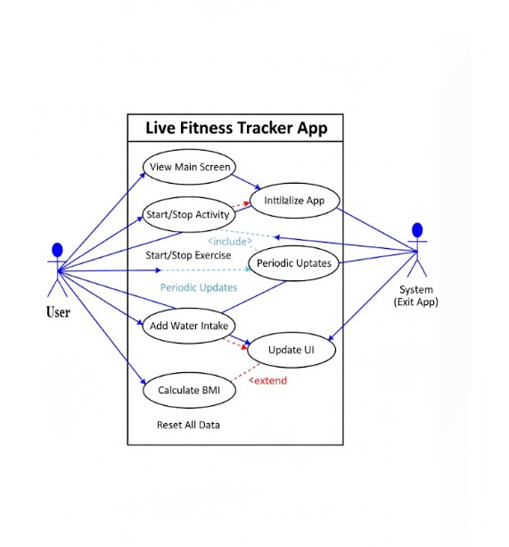
Figure 3.1: Use Case Diagram

3.2.2 Activity Diagram
The Activity Diagram shows the sequence of steps within the FitTrack system’s core workflows. It maps actions, decision points, and parallel flows to clarify how users and the system progress through tasks—from initial authentication to daily health monitoring and data management. See Figure 3.2 for the Activity Diagram.
- Onboarding Flow: The activity begins with the user choosing between Sign Up or Login. Upon successful authentication, the system flows into the Setup phase where the user inputs their weight and height.
- Automated Processing: Once the physical metrics are entered, the system performs a parallel action: it Calculates the BMI and simultaneously Initializes Exercises and Timers tailored to the user’s profile.
- Dashboard Interaction: After initialization, the user is directed to the Main Dashboard. From here, the user can choose to view multiple data streams such as History, Live Activities, Water Intake, BMI, and overall Stats.
- User Actions & Decision Points: The diagram illustrates specific decision-based actions. A user can choose to Toggle an Activity, Add Water Intake, or perform a Reset of all Data.
- Synchronization Loop: If a user decides to Recalculate BMI, the system processes the new data and triggers a Refresh Dashboard action, ensuring that all visual stats are updated in real-time before returning the user to the main view.
- Termination: The process concludes when the user completes their session or closes the application, as indicated by the 'End' state in the workflow.

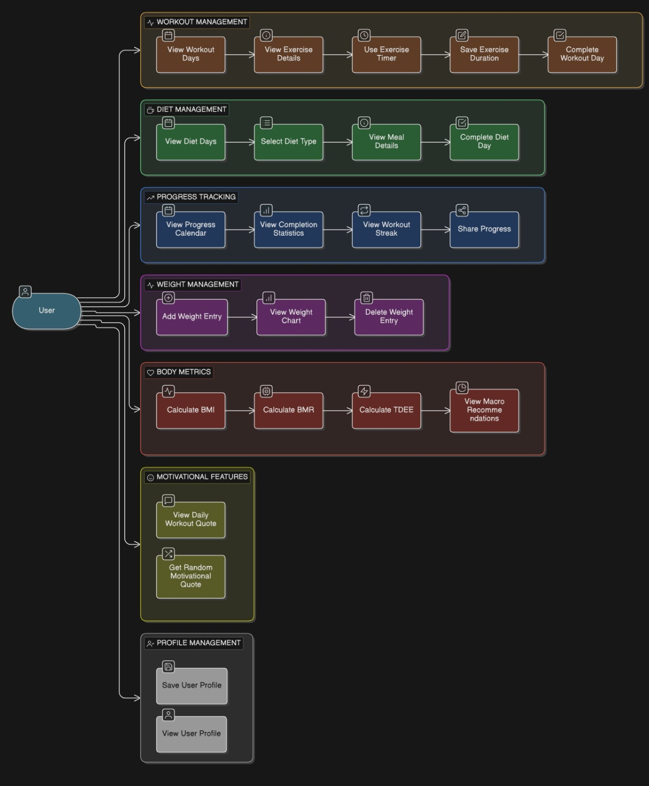
Figure 3.2: Activity Diagram

ER Diagram
The Entity Relationship (ER) Diagram defines the main data entities, their attributes, and relationships. See Figure 3.3 for the ER Diagram.
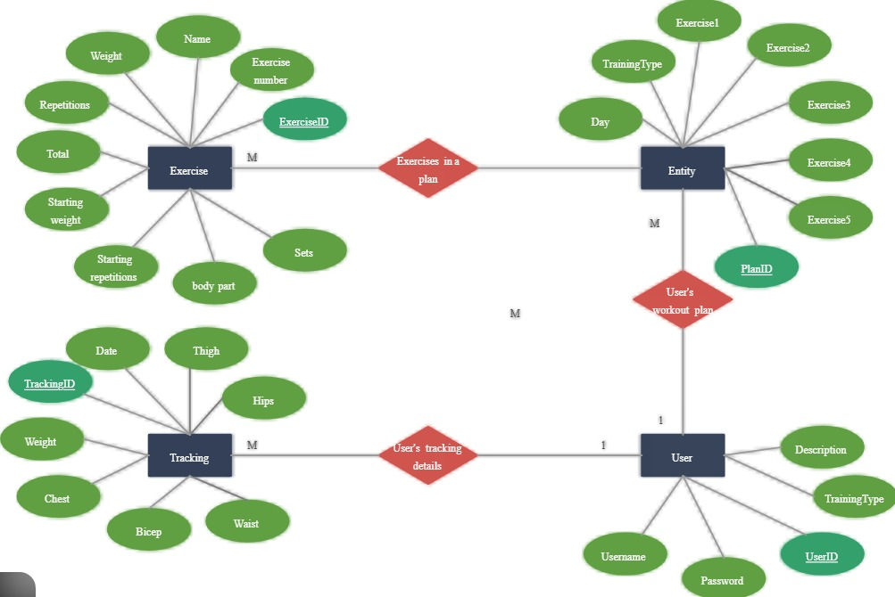

Figure 3.3: ER Diagram

1.4 DFD Level 0: FitTrack System (Context Diagram)

A Level 0 Data Flow Diagram (DFD), often called a Context Diagram, is the bird's-eye view of your system. It focuses on the high-level boundaries and how data travels between the system and the outside world.
- Entities: User (Athlete/Patient), Admin, Fitness Tracker (Wearable API).
- Input Data: Profile Info, Workout Logs, Daily Meals, Heart Rate/Steps.
- Output Data: Progress Reports, Health Insights, Daily Reminders, Dashboard View.
- 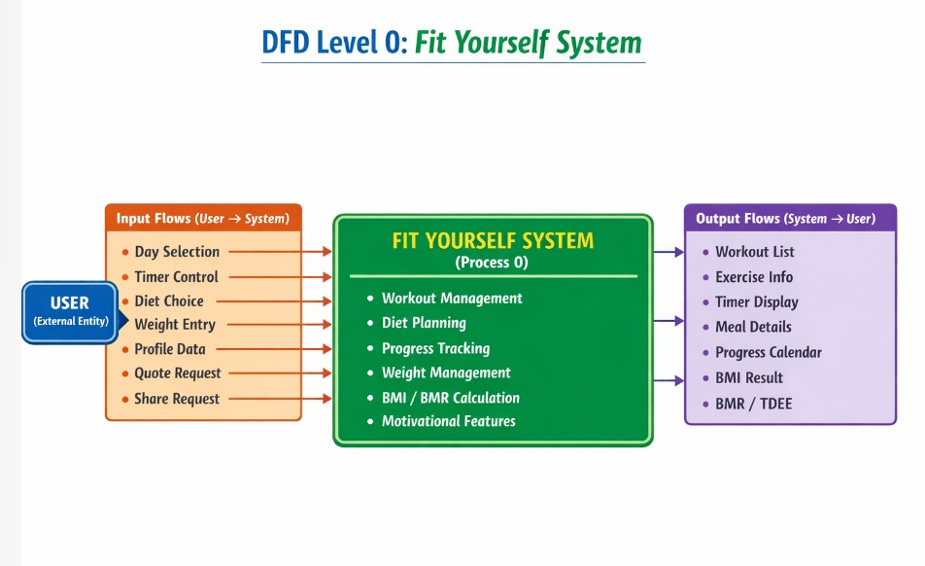

1.5 DFD Level 1: Detailed Process Flow

In a Level 1 Data Flow Diagram, you dive deeper into the system's inner workings. Instead of one single bubble, you break the system down into its core functional parts.
Process ID | Process Name | Data Flow Description
P1 | User Management | Profile creation, authentication, and physical metric updates (Age, Weight, Height).
P2 | Activity Tracking | Processing real-time data like steps, distance, and calories burned.
P3 | Nutrition Logging | Recording daily food intake and calculating total calorie/macronutrient consumption.
P4 | Data Analysis & Reporting | Comparing user activity against goals and generating weekly/monthly health charts.
P5 | Admin Controls | Managing exercise libraries, user databases, and system 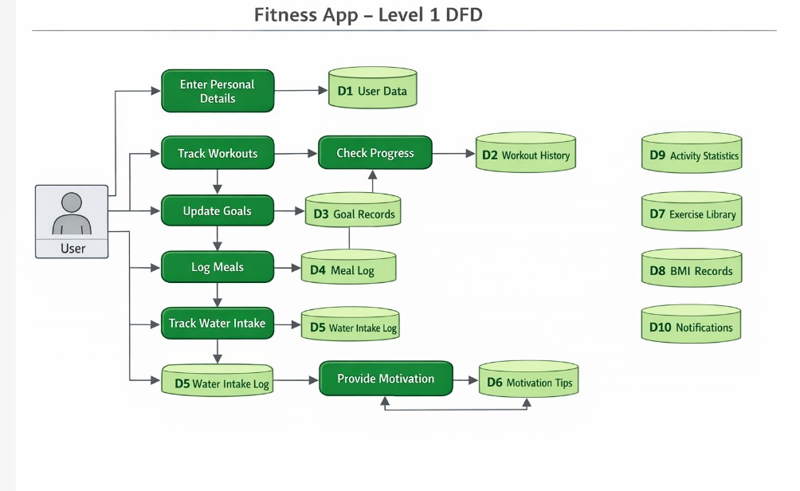maintenance.

Chapter 4: Accomplishment
This chapter outlines the steps undertaken to design and develop the FitTrack application. It describes how the project was planned, the methods followed during development, and the outcomes achieved at each stage. The goal was to ensure that each component, from requirement gathering to testing, was carried out systematically to meet both the functional and health management objectives of the system.

4.1 Preliminaries
The preliminary phase of the FitTrack project focused on understanding the fitness-related challenges faced by individuals and preparing the conceptual, technical, and organizational foundation required for system development. This phase was essential to ensure that the application would address real-world health problems and provide meaningful support through a structured digital platform.
- Problem Understanding and Background Study: The first stage involved analyzing the daily health management habits of individuals. Despite the growing awareness of fitness, many people encounter difficulties in gathering accurate and organized data about their physical activities, calorie expenditure, and BMI tracking. Most available health tools are either fragmented across different platforms or require expensive wearable hardware, leading to inconsistent tracking and a lack of long-term motivation. A background study revealed that while general health apps exist, they often lack a simplified, integrated approach for daily activity logging and personalized BMI-based guidance. This gap highlighted the need for a dedicated mobile application designed specifically to serve as a comprehensive personal fitness companion.
- Requirement Identification and User Expectations: To better understand user needs, informal discussions were conducted with fitness enthusiasts and health-conscious individuals. These interactions helped identify essential requirements such as:
  - Easy access to real-time activity tracking (walking, running, swimming).
  - Automated BMI calculation based on user physical metrics.
  - Structured tracking of daily water intake.
  - Visual representation of progress through history and statistics.
  - A simple and intuitive interface suitable for all age groups.
Based on these insights, both functional and non-functional requirements were defined to ensure usability, security, and real-time data reliability.
- Technology and Resource Selection: Appropriate development tools were selected to ensure performance and maintainability:
  - Flutter Framework: Chosen for building a responsive Android application with a modern user interface.
  - Dart Programming Language: Used for implementing core fitness logic, timers, and UI behavior.
  - Firebase Services: Provided secure authentication and real-time database synchronization for health data.
  - Design Planning Tools: Wireframes were prepared to visualize the dashboard layout and user activity flow before implementation.
- System Planning and Structural Design: A clear system workflow was planned to ensure a seamless experience. System models such as Use Case Diagrams and Activity Diagrams were conceptualized to define how user data (weight, height, and steps) would flow into the BMI and activity modules. This structured planning ensured that development proceeded in a goal-oriented manner.

4.2 How the Work Was Done
The development of the FitTrack application followed a systematic and iterative methodology. Each component was implemented step by step, tested individually, and then integrated into the complete system.
- Application Architecture Development: The system architecture was designed to connect the Flutter frontend with the Firebase backend. The application was divided into several functional modules:
  - Authentication Module: Secure login and sign-up.
  - Setup & BMI Module: Physical data entry and calculation logic.
  - Main Dashboard Module: Central hub for viewing health stats.
  - Activity & Exercise Module: Tracking timers and live movement.
  - History & Analytics Module: Storing and displaying past performance.
- Frontend Implementation Using Flutter: The graphical interface was developed using Flutter’s widget-based architecture. Special attention was given to simplicity and structured navigation. The home interface was designed as a Main Dashboard featuring five major components:
  - History View: Chronological logs of past workouts.
  - Live Activities: Real-time tracking of movement.
  - Water Intake: Simple logging for daily hydration.
  - BMI Display: Real-time visibility of current body mass index.
  - Stats View: Visual charts for calorie and time analysis.
- Backend Integration and Data Synchronization: Firebase Authentication was implemented to manage user profiles securely. Firebase Realtime Database was integrated to store state data like runningCalories, totalSteps, and walkingTime. Any activity toggled by the user or BMI recalculation is instantly synchronized, ensuring the dashboard reflects accurate information immediately.
- Action & Control Implementation: A specialized "User Action" layer was designed to allow users to interact with the system dynamically. This includes toggling specific exercises, adding water logs, and a "Reset All Data" feature for a fresh start. These actions were linked to the HomePageState to ensure data integrity across the app.
- Testing and Quality Assurance: Comprehensive testing was conducted to validate system performance:
  - Functional testing: Verified that BMI calculations and calorie logic were mathematically accurate.
  - Usability testing: Ensured the dashboard was intuitive for quick logging.
  - Synchronization testing: Confirmed that data remains consistent after a "Recalculate BMI" action.
- Final Deployment and System Outcome: After successful testing, the FitTrack application was deployed as a functional Android system. The completed application acts as a centralized fitness platform that assists users in maintaining their health goals, monitoring their physical progress, and making informed wellness decisions with confidence.

Chapter 5: Results

5.1 Application Features and Interface Overview
In this chapter, we present the key features and functionalities of the FitTrack application through screenshots and detailed descriptions. The purpose of this section is to illustrate how the system operates in practice and how users interact with the various fitness and tracking modules of the application.
FitTrack provides a clean, intuitive, and user-friendly interface that allows fitness enthusiasts to navigate easily between various sections of the system. The design focuses on simplicity and visual clarity so that users, ranging from beginners to advanced athletes, can quickly log workouts and access health data without technical friction.
The application begins with a welcome and authentication interface where users can register or log in securely. After a successful login, users are directed to the main dashboard, which presents three primary options:
- Workout Logging: For real-time tracking of exercises and sets.
- Progress Analytics: To visualize gains and performance trends over time.
- Exercise Library: A structured database of movements and routines.
These sections are clearly organized to help users manage their fitness journey in a structured manner. The screenshots included in this chapter demonstrate the application’s organized layout, readable performance metrics, and smooth navigation flow. Users can efficiently explore routine templates, body weight logs, historical data, and personalized goals. Each screen is designed to minimize distraction, ensuring users can focus on their physical performance while accessing relevant data quickly.
Overall, the interface emphasizes accessibility, consistency, and ease of use, ensuring that users can rely on FitTrack as a practical digital companion during their training sessions. The authentication module allows users to securely create an account and log into the system. New users can register using a streamlined form, while existing users can access their profiles using their credentials. The system ensures secure access and protects personal health data through Firebase authentication.

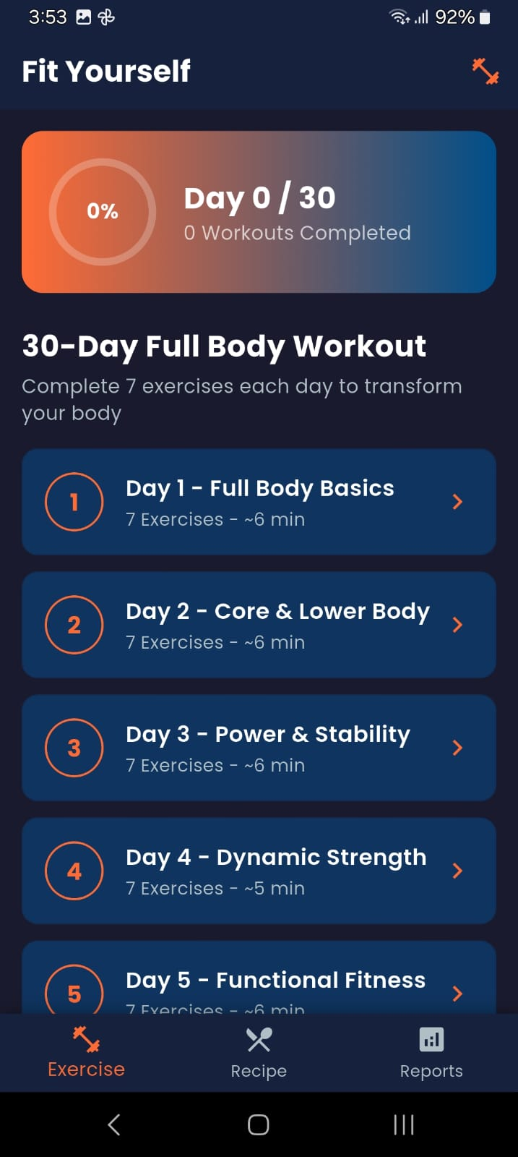

Figure 5.4: 30-Day Workout Challenge Screen

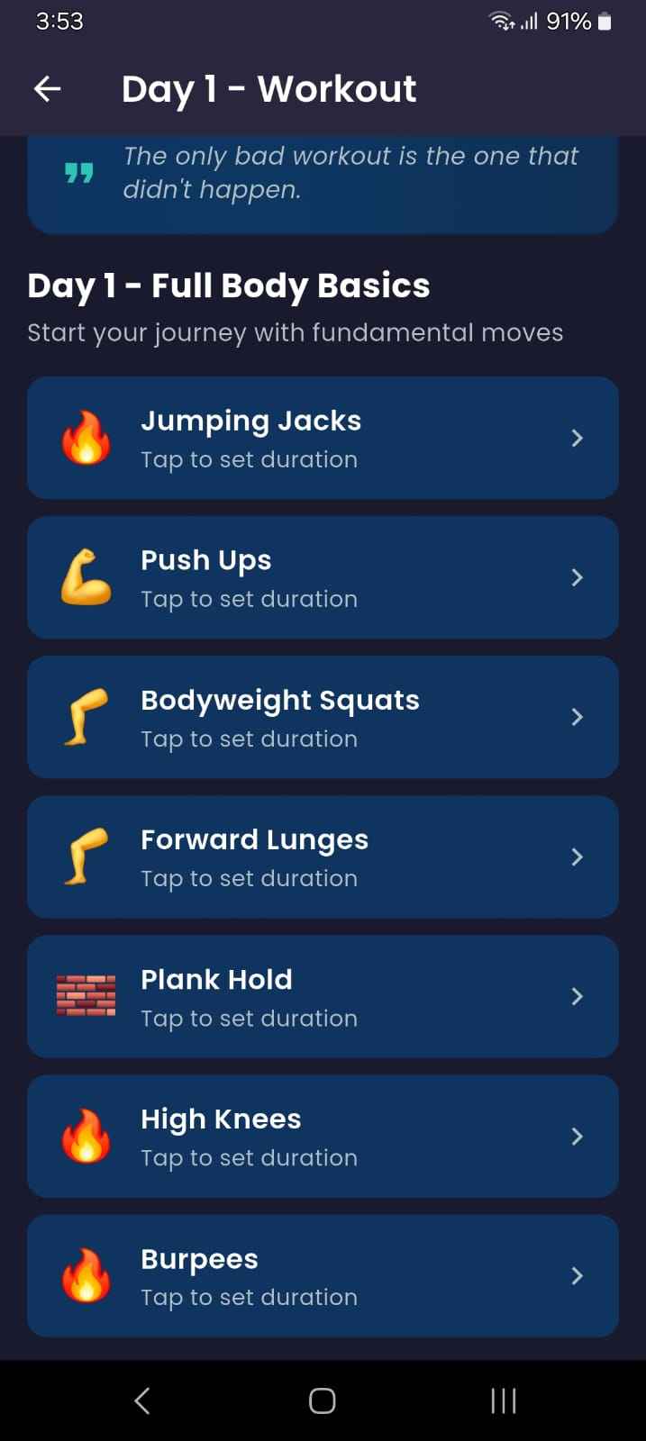

Figure 5.5: Left: 30-Day Workout Plan. Right: Day 1 Exercise List

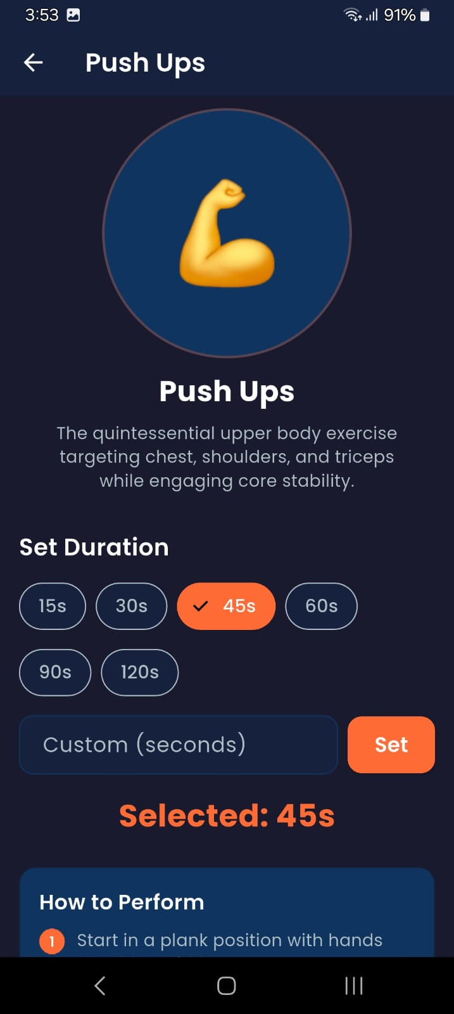

Figure 5.6: Workout Detail Screen (Push Ups) with Duration Settings

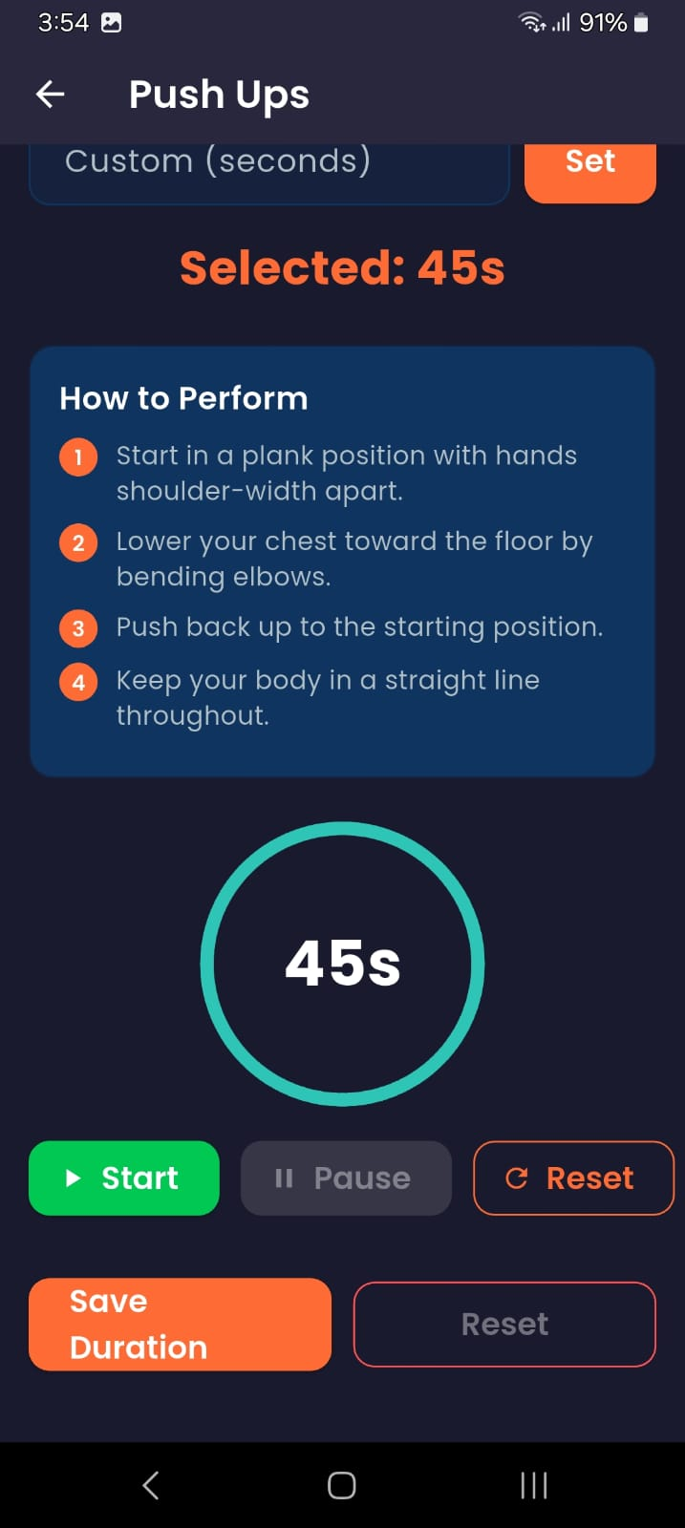

Figure 5.6: Left: Exercise Timer. Right: How to Perform & Control Panel

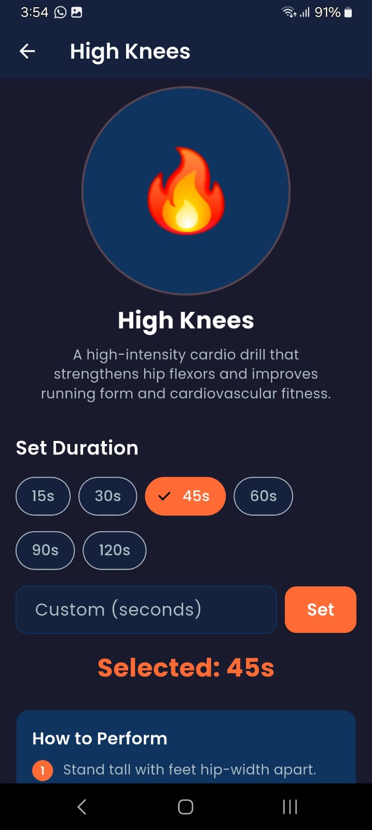

Figure 5.7: Exercise Detail View: High Knees Description and Duration Setup

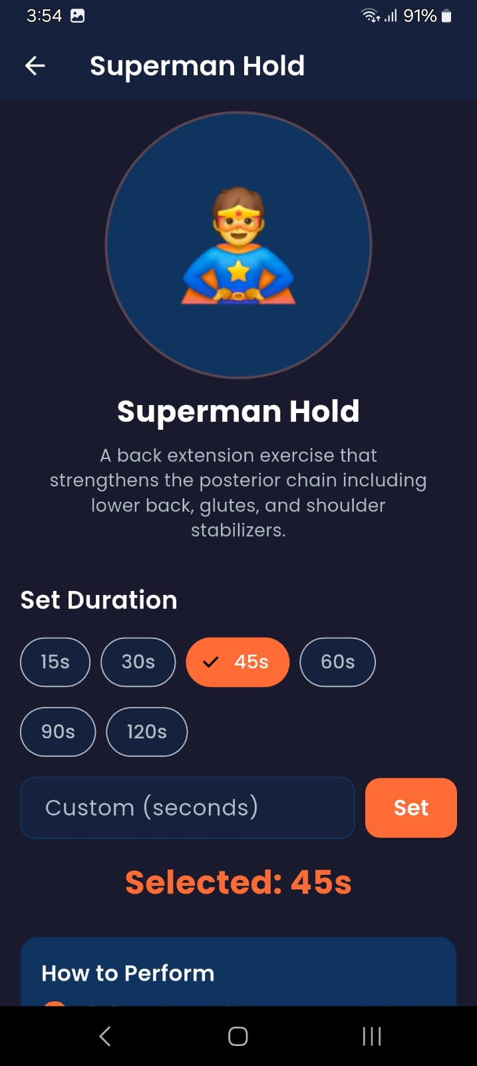

Figure 5.7: Left: High Knees Setup. Right: Superman Hold Setup

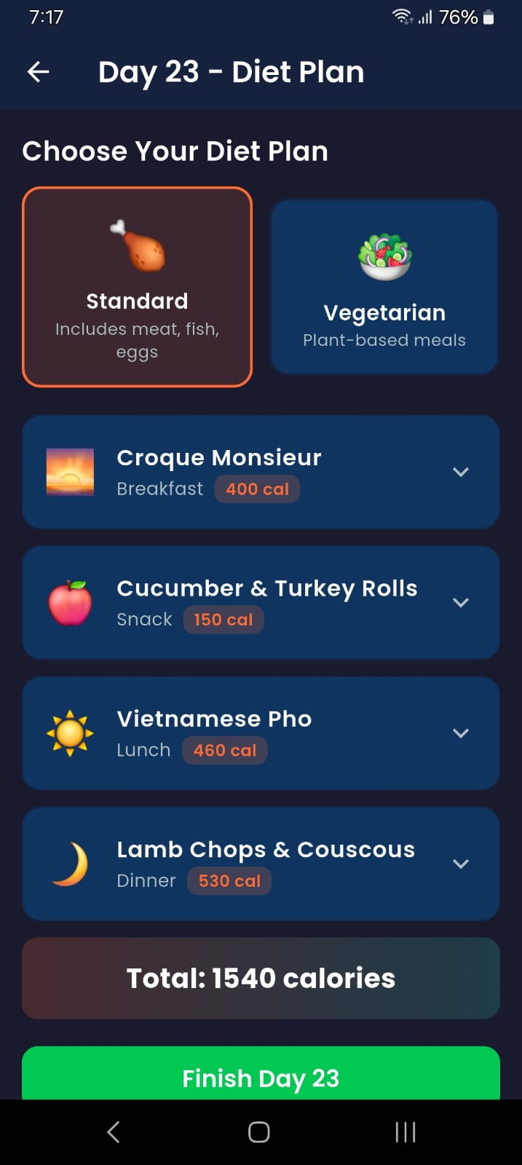

Figure 5.8: Diet Plan Interface: Standard and Vegetarian Meal Options

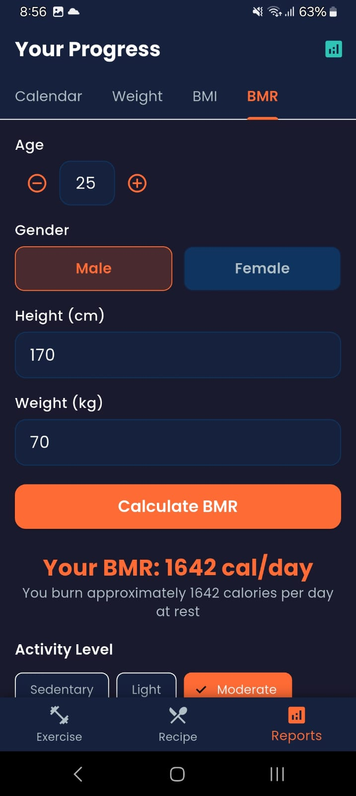

Figure 5.9: Progress Report: BMR (Basal Metabolic Rate) Calculator Interface

Chapter 6: Conclusion
This project represents an important step toward creating a localized, user-centered digital fitness platform that supports individuals in maintaining their health by providing comprehensive, reliable, and easily accessible tracking tools in one application. The FitTrack app successfully achieves its primary objectives by integrating secure user authentication, automated BMI calculations, structured workout tracking, and water intake monitoring. By combining real-time activity tracking, exercise guidance, and data-driven statistics, the system offers a cohesive and practical solution tailored to the needs of both beginners and fitness enthusiasts.
Throughout the development process, several challenges were encountered, including requirement analysis for health metrics, data organization for activity logs, and system design for real-time synchronization. Each phase—from system modeling using use case, activity, and ER diagrams to implementation and testing—provided valuable insights into designing a scalable, health-oriented mobile application. Special emphasis was placed on usability and data visualization, ensuring that users can easily interpret their fitness progress. The final outcome is a functional prototype that demonstrates how mobile technology can enhance personal wellness, improve health awareness, and promote a consistent fitness lifestyle within a secure and well-structured digital environment.

6.1 Restrictions
During the development of the FitTrack application, several practical and technical constraints played a role in shaping the project:
- Restricted Database Resources: The application used free-tier backend services, which imposed limitations on database storage and real-time synchronization speed for high-frequency activity data.
- Internet Connectivity Dependency: While core features like viewing existing BMI and workout history can be accessed with minimal connectivity, essential operations—including authentication and real-time cloud synchronization—require an active internet connection through Firebase.
- Platform-Specific Development: FitTrack was developed and tested exclusively for the Android platform using Flutter. Due to time limitations, cross-platform optimization for iOS could not be performed in this cycle.
- Hardware Limitations: The app relies on mobile sensors for step counting and activity tracking; therefore, the accuracy of the data is limited by the specific hardware capabilities of the user's smartphone.

6.2 Limitations
Despite fulfilling its core objectives, the FitTrack application exhibits several limitations:
- Restricted Health Data Integration: The system currently relies on manual user input for metrics like weight and water intake, lacking integration with third-party wearable devices like smartwatches.
- Partial Offline Functionality: Users can browse previously loaded stats, but logging new workouts or updating profiles depends on continuous internet connectivity for cloud storage.
- Simplified Activity Recognition: The system distinguishes between basic activities but does not yet support advanced posture detection or complex exercise form correction using AI or camera sensors.

6.3 Future Work
Looking ahead, the FitTrack project holds significant potential to evolve into a more intelligent and comprehensive wellness platform:
- Integration with Wearable Devices: Future versions could sync data directly from Apple Watch, Fitbit, or Garmin to provide more accurate health metrics.
- AI-Based Personal Trainer: Incorporating machine learning to provide personalized workout recommendations based on user performance and history.
- Diet & Nutrition Expansion: Adding a comprehensive food calorie database and barcode scanner for more detailed nutritional tracking.
- Gamification & Social Features: Introducing challenges, badges, and the ability to share progress with friends to increase user motivation and engagement.
- Cross-Platform Compatibility: Extending the app to iOS and web-based versions to ensure accessibility for a wider audience.

References
[1] “Google Fit: Health and Activity Tracking,” accessed: 2026-02-25. [Online]. Available: https://www.google.com/fit/
[2] “MyFitnessPal: Calorie Counter and Diet Tracker,” accessed: 2026-02-25. [Online]. Available: https://www.myfitnesspal.com/
[3] “Healthline: BMI Calculator and Health Metrics,” accessed: 2026-02-25. [Online]. Available: https://www.healthline.com/health/bmi-calculator
[4] “Flutter: UI toolkit for building natively compiled applications,” accessed: 2026-02-25. [Online]. Available: https://flutter.dev/
[5] “Firebase: Backend platform for mobile and web apps,” accessed: 2026-02-25. [Online]. Available: https://firebase.google.com/

Appendix A: Source Code
This appendix provides a concise overview of supplementary materials related to the FitTrack system. It summarizes additional references, design notes, and technical resources that support the development and implementation of the application.
- Source code excerpts: Selected samples demonstrating the BMI calculation logic, Firebase real-time sync, and the Flutter dashboard UI design.
- User manuals: Step-by-step guides for users to set up their profiles, log activities, and interpret their health statistics.
- Technical documentation: Detailed descriptions of the system architecture, including the HomePageState logic and the relationships between ActivityHistory and Exercise modules.

